Feature-based visual tracking of agricultural implements

Trevor P. Stanhope*, Viacheslav I. Adamchuk**

*McGill University, Montreal, QC (e-mail: trevor.stanhope@mail.mcgill.ca).
**McGill University, Montreal, QC (Tel: 514-398-7657; e-mail: viacheslav.adamchuk@mcgill.ca)
Abstract: Systems which utilize implement-mounted cameras for machinery feedback, e.g. row crop cultivators and sectional pesticide sprayers, can be upgraded to provide high-accuracy ground speed and tracking feedback. This process, known as visual tracking, may be used to compensate for implement dynamics in complement with RTK-GNSS receivers and/or other sensors. Several variations of the SURF, SIFT, and ORB feature-descriptor algorithms were evaluated for their suitability using a 3 GB dataset of 640×480 pixel videos of six surfaces (gravel, asphalt, grass, seedlings, corn residue, and pasture) for speeds from 1 to 5 m/s. Feature-descriptor matching of consecutive video frames was tested using two methods of the k-Nearest Neighbors (kNN) algorithm: (1) 1NN with cross-checking, and (2) 2NN with the ratio-test. Ground speed and tracking direction were calculated using a fast histogram filter to reject bad matches between frames. When comparing visual tracking to RTK-GNSS, ORB with CLAHE pre-processing (CLORB) and 1NN cross-checking was found to be the most robust with respect to real-time applications. For 95% of measurements, CLORB achieved errors under 0.23 m/s. Similar accuracy was achieved with SURF, U-SURF, and SIFT, but CLORB was capable of producing estimates in real-time (25 Hz), whereas SURF, U-SURF, and SIFT were only capable of 15 Hz or less.
Keywords: Computer-vision, feature description, visual tracking, control systems.

1. INTRODUCTION
An essential sensor feedback required by many agricultural control systems is real-time estimation of machinery motion vectors. Vector data has numerous applications for control of agricultural tractors and implements, e.g. wheel slip detection (Thansandote, 1977). Several different techniques exist for acquiring vector data, each of which have advantages and disadvantages depending on the environment and required level of precision and accuracy.
For most applications, real-time kinematic (RTK) global navigation satellite system (GNSS) receivers are the preferred method for determining both the vector and positional data of the vehicle. Field operations which require high accuracy and precision, such as tractor auto-steering, utilize RTK-GNSS receivers which are capable of up to 1 cm precision (Gan-Mor, 2007). With respect to implements, the position of the toolbar relative to the tractor is dynamic, e.g. for pull-type and articulated-hitch implements, and therefore a secondary receiver is needed on the implement itself.
An alternative to RTK-GNSS for determining ground speed is mechanical detection with rotary encoders in contact with the soil surface, commonly known as fifth-wheels. Fifth-wheels are advantageous because they are low-cost and provide a sufficient degree of precision in many applications , e.g. seed metering. However, relative to fifth-wheels are limited in that they only provide 2 degrees-of-freedom, i.e. acceleration and velocity along a single axis. Additionally, fifth-wheels are contact sensors and are therefore prone to errors due to slippage on some surfaces (Tompkins, 1988).
Visual tracking with cameras is a non-contact approach which does not suffer from slip and provides 4 degrees-of-freedom for a monocular (single camera) system. Visual tracking refers to the process of determining the movement of a non-stationary platform or vehicle by analyzing consecutive images captured by an on-board camera. Visual tracking is valuable for many robotics applications, such as simultaneous localization and mapping (Nistér, 2004), and can be incorporated into systems which already utilize cameras for plant detection, such as cultivator guidance systems or sectional pesticide sprayers. However, visual tracking is computationally intensive. Thus, with respect to real-time applications, e.g. embedded systems, it is important that the tracking algorithm be accurate yet computationally efficient.
The goal of this study was to compare the efficiency of several feature-descriptor algorithms for monocular visual tracking. Motion vectors of an agricultural vehicle were determined for speeds from 1 to 5 m/s on six surfaces to determine the reliability of each method with respect to computational efficiency, accuracy and robustness.
2. MATERIALS AND METHODS
2.1 Feature Detection and Description
In order to identify the motion between consecutive frames of a video stream, a robust approach is to identify distinctive features which can be tracked (Gauglitz, 2011). A distinctive feature, also known as a keypoint, is a sub-region of an image which exhibits maximum variation within its neighborhood. Distinctive keypoints are identified within an image using algorithms known as feature detectors, Once distinct features have been located, the region around each feature must be described in order to find the same feature in another overlapping image: This process of generating descriptive parameters for a feature is known as feature description. After features and descriptors have been generated for both images, a classification algorithm such as k-Nearest Neighbors can be employed to find matches between the two sets (Boiman, 2008).
2.2 SIFT Feature-Descriptor
The Scale-Invariant Feature Transform (SIFT), proposed by Lowe et al. (2004), is a highly effective algorithm which incorporates both feature detection and description. SIFT is based on the Laplacian of Gaussian (LoG) which acts as a blob detector for finding distinct features of different sizes by varying a scaling parameter (σ). However, LoG is computationally expensive, so the SIFT algorithm detects local extremas of the image by applying a Difference of Gaussians (DoG) filter as an approximation of LoG which performs well despite noise compared to other detectors (Rosten, 2010).
2.3 SURF Feature-Description
Speeded-Up Robust Features (SURF) was developed as an improvement upon the SIFT algorithm (Bay, 2008). Like SIFT, SURF is a scale and rotation-invariant keypoint detector and descriptor. Convolution with Gaussian second order derivatives in LoG is computationally expensive, so SURF offers improved computational speed over SIFT by approximating LoG with box filters and using pre-computed integral images.
2.4 ORB Feature-Description
Oriented FAST and Rotated BRIEF (ORB) was developed by Rublee et al. (2011) as a rotation-invariant feature-descriptor algorithm with comparable performance to SIFT and SURF but faster computational speed. First, the FAST feature detector is used to find keypoints, and then the Harris corner measure is applied to find the N best points. In order to achieve rotation-invariance, ORB assigns orientations to each FAST keypoint, a process known as Oriented FAST (oFAST). The Harris-score is used in place of the FAST-score to improve reliability, albeit at a slight cost to speed. A second improvement in ORB was the inclusion of the Rotation-Aware BRIEF (rBRIEF) algorithm, a binary-descriptor algorithm based on BRIEF, which “steers” BRIEF according to the orientation of the keypoints. rBRIEF computes the intensity weighted centroid of a 15×15 region around each keypoint. The direction of the vector from this corner point to centroid gives the orientation. This process produces distinctive feature-descriptors at relatively low computational cost (Rublee, 2011).
2.5 CLAHE
Histogram equalization is a pre-processing technique for adjusting pixel intensities to enhance the contrast and edge definition of images. However, global histogram equalization can cause degradation of some features. To address this, adaptive histogram equalization (AHE) partitions the image into equally sized rectangular tiles, e.g. 8×8 tiles (Zuiderveld, 1994). For each tile, the sub-histograms are calculated and used to equalize each tile independently. However, AHE is still prone to over-amplification of noise in homogenous regions.
To address over-amplification, contrast limited adaptive histogram equalization (CLAHE) was proposed by Pizer et al. in 1998. CLAHE uses the slope of the transformation function in the neighborhood of a given pixel value to perform contrast amplification. The amplification is proportional to the slope of the neighborhood's cumulative distribution function (CDF). CLAHE limits the amplification by clipping the histogram at a predefined value, known as the clip limit, before computing the CDF. As a pre-processing technique, CLAHE has a positive effect on edge enhancement (Figure 1), but adds computational expense because it requires computing a histogram and CDF for each of the tiles. CLAHE has been demonstrated to be an effective technique for real-time contrast enhancement (Yadav, 2014). CLAHE has been implemented as a component of histogram-binary combined corner enhancement (HBCCE) and was found to improve the repeatability of feature detectors from 10% to 40% with negligible reduction in speed (El Harraj, 2015).
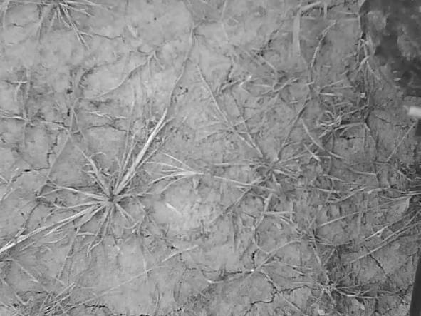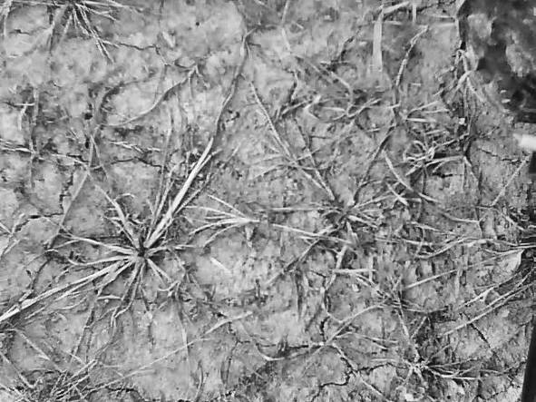
Fig. 1. Comparison of grayscale (left) and CLAHE (right).
2.6 kNN Matching
The k-Nearest Neighbors algorithm (kNN) is a method for pattern matching in non-parametric feature spaces, and is commonly used in computer-vision and machine learning. With respect to visual tracking, kNN is used to find the k-nearest neighbors in feature-space of each keypoint between the descriptor vectors sets for two consecutive images. Implementations of the kNN algorithm in computer vision commonly search for either one or two nearest neighbors, referred to as 1NN and 2NN, respectively. For example, 2NN produces two matches for each feature. Lowe et al. (2004) proposed the ratio-test to filter matches produced by 2NN: For each feature in the first image, two matches are calculated in the second, the distance metric of each neighbor is compared, and the match is only accepted if the ratio between the two distances is less than some threshold (a ratio of 0.7 is typical). However with respect to 1NN, calculating a single neighbor can result in poor performance as a match will be found for every single feature, even unmatchable ones. To address this, 1NN is often used with cross-checking. Cross-checking is based on the principle that the distance from one keypoint (A) to another keypoint (B) is not necessarily an invertible statement, i.e. B may be the closest point to A, but A may not be the closest point to B. Cross-checking computes 1NN for both directions, A-to-B and B-to-A, and a match is only accepted if A and B are closest for both directions (Figure 2).
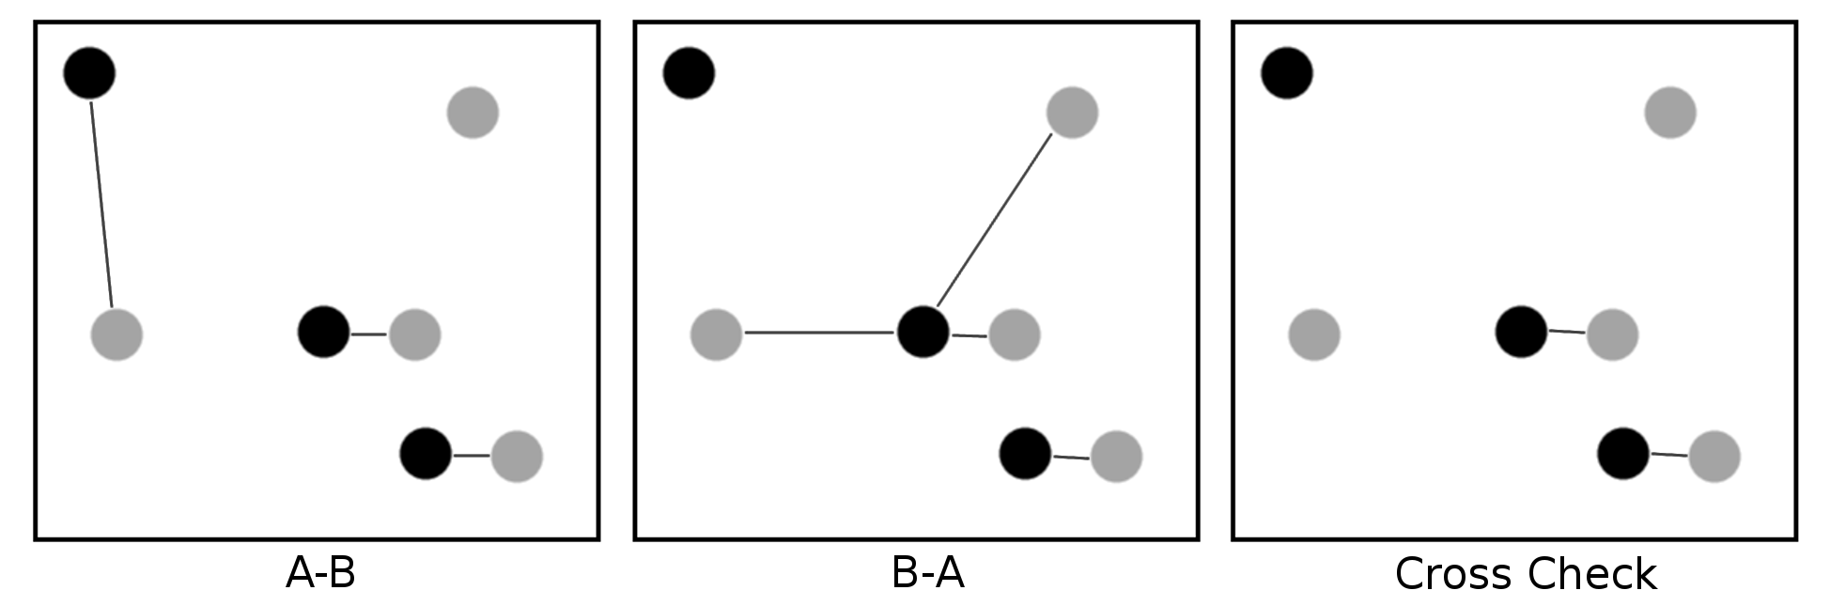
Fig. 2. Demonstration of 1NN matching with cross checking.
2.7 Experimental Setup
A weatherproof camera with a resolution of 640×480 pixels was mounted to the front of a John Deere 850D Gator (John Deere, Moline, Illinois, USA) at an orthogonal viewing perspective to the ground surface and a height of 1.0 m (Figure 3). The camera had an aperture of 2.4 (F), a 6 mm focal point (f), and a 8.47 mm (1/3 inch) color CMOS sensor with an aspect ratio of 4:3 (Shenzhen Yufei Technology Co., Shenzhen, China). To maximize the overlap between consecutive images at higher travel speeds, the camera was oriented width-wise such that the 640 pixel axis of the camera sensor was aligned with the direction of travel. The camera was capable of automatic white-balance adjustment and had a frame capture rate of 25 Hz.
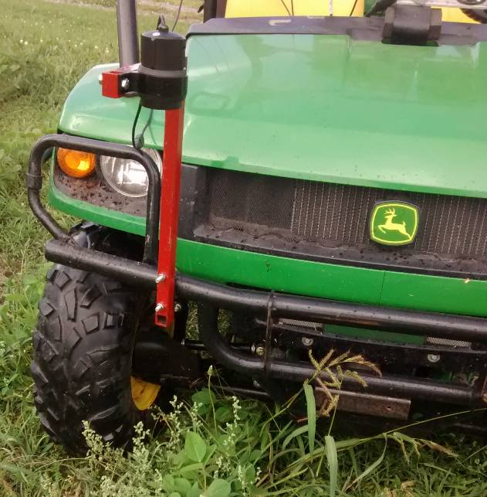
Fig. 3. Test vehicle and mounting bracket for camera.
After installation of the camera bracket, 10 calibration images were taken of a 9×7 checkerboard pattern in order to determine the camera distortion model (Lee, 2009). Corner detection was conducted on each image to find the geometric position of the 48 distinct corners. For each image, the corner points were used to fit a Brown-Conrady radial and tangential distortion model (1). The distance coefficients of each image were averaged to generate the distance coefficients used for radial and tangential distortion correction. Using the known dimensions of the squares (30 mm by 30 mm), a resolution of 1.0 mm/px was achieved with this configuration.
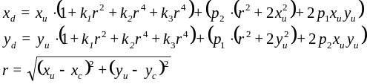 (1)
where radial terms k₁, k₂, and k₃ are -3.21×10¹, -6.03×10⁻³, and -3.22×10⁻³, respectively, and tangential terms p₁ and p₂ are -7.13×10⁻² and 2.41×10⁻⁷, respectively.
A Trimble AgGPS 542 RTK-GNSS rover receiver (Trimble Navigation Ltd., Sunnyvale, California, USA) was mounted to the test vehicle. The rover was configured to produce $GPVTG and $GPGGA NMEA-0873 strings at the maximum rate of 20 Hz. The accompanying base station was positioned in an open area, and all trials were conducted within 2 km of the base station. An application was developed using the Python programming language (vers. 2.7.11) (Python Software Foundation, Wilmington, Delaware, USA) and OpenCV (vers. 2.4.9) (Itseez, Inc., San Francisco, California, USA) to capture videos with low latency (less than 0.01 ms/frame) and generate accompanying RTK-GNSS logs with time-stamps corresponding to each image.
As specified by ISO 12188-2, the visual tracking system was evaluated from 1 to 5 m/s on six surfaces: asphalt, gravel, turf grass, seedlings, corn residue, and pasture (Figure 4).
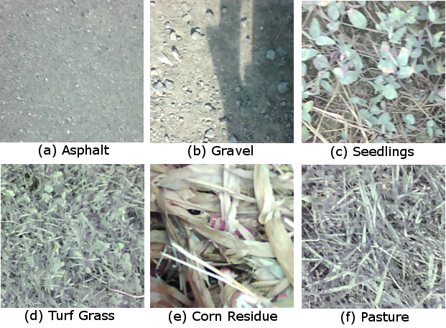
Fig. 4. Sample images of each of the six surfaces considered.
For each trial, the logging system and RTK-GNSS receiver were activated. Once an accurate satellite signal was acquired, the vehicle was engaged into gear and the accelerator was steadily applied until 5 m/s was reached, at which point the vehicle was decelerated back to rest. During each trial, the operator attempted to maintain an average acceleration of 0.25 m/s² and a trial duration of approximately 45 s. For each surface type, five replicates were conducted for a total dataset consisting of 32699 images.
2.8 Data Processing
The visual tracking algorithm consisted of 9 sequential operations (Figure 5). First, the next RGB image was read from the camera buffer and converted to gray-scale. In the case of CLORB, an additional pre-processing step of CLAHE was performed on the gray-scale image. Next, lens distortion was corrected for. Then, the feature-descriptor algorithm was executed to detect keypoints in the image followed by kNN to match keypoints of the current image with the those of the previous image stored in memory. Polar vectors were then computed from the displacement between matches, and a histogram vector filter was applied to eliminate outlying vectors. Lastly, the dominant vector direction and displacement were calculated using the set of all inlier vectors. All processing of the video data was computed in a single thread on a Intel Xeon E31225 at 3.1 GHz to simulate performance similar to a high-end embedded system.
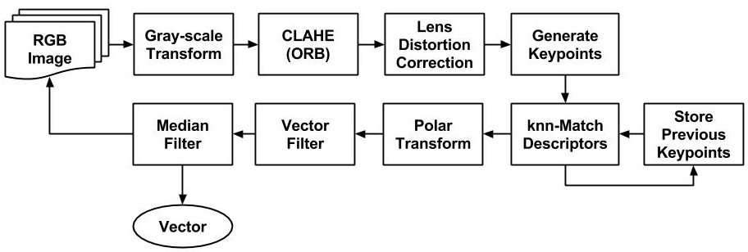
Fig. 5. Process diagram of the visual tracking algorithm.
Five feature-descriptor algorithms were evaluated: SURF, U-SURF, ORB, ORB with CLAHE pre-processing (CLORB), and SIFT. Additionally, for each feature-descriptor algorithm, both 1NN with cross-checking and 2NN with the ratio-test (threshold of 0.7) were evaluated, for a total of 10 algorithm configurations. With respect to SURF and U-SURF, common parameters discussed in the literature and by Bay et al. (2008) were used, specifically: four (4) Gaussian pyramid octaves and two (2) images within each octave of a Gaussian pyramid. As per the literature, kNN matching of SURF floating-point descriptors was conducted using the L² norm distance metric. With respect to SIFT, algorithm parameters similar to that used in Lowe et al. (2004) were used: the number of octave layers was set to three (3), and the contrast and edge thresholds were set to 0.04 and 10, respectively. Again, kNN matching of SIFT floating-point descriptors was conducted using the L² norm distance metric. With respect to ORB, two variants were evaluated: ORB and ORB with CLAHE pre-processing (CLORB). Both algorithms were configured to use an edge threshold of 31, a patch size of 31, eight (8) pyramid levels, and two (2) randomized pairs for BRIEF intensity comparisons. The kNN matching of ORB binary descriptors was conducted using the Hamming norm distance metric. In the case of CLORB, CLAHE with a clip limit of 2 and a tile grid size of 8×8 was used.
kNN matching for visual tracking is prone to non-parametric errors, therefore it is necessary to filter the set of all detected vectors to remove any outliers. With respect to visual tracking of orthogonal images, the set of motion vectors was assumed to be unimodal, so a computationally inexpensive histogram filter was employed (2). First, a 360 bin histogram (H) of θ-values was generated. Next, the discrete second-order gradient (3) of the histogram's cumulative summation (4) was used to calculate an array of differences (D). The centroid vector angle corresponding to the maximum value of the gradient array was found (θ_{C}) using the argmax function (5). The best estimate for the motion vector (v_{m}) between two consecutive frames was assumed to be the median and mean of the sets of all vector radii (R_{k}) and all vector angles (ϴ_{k}), respectively, for all vectors within a tolerance of 1˚ of θ_{C}:
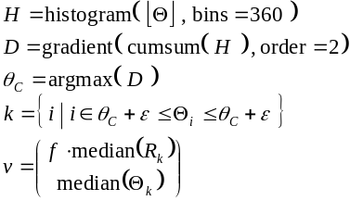 (2)
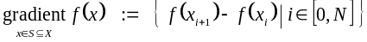 (3)
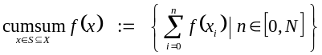 (4)
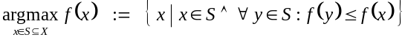 (5)
This approach was effective for determining the dominant vector even in the case of persistent shadows or non-moving objects in the field of view (e.g. the vehicle frame), and only required 2 ms per 640×480 image. Figure 6 shows an example of the histogram filter rejecting outlier vectors.
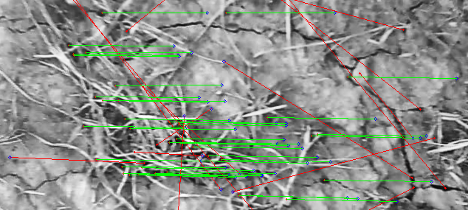
Fig. 6. Visual tracking with outlier vector filtering.
For subsequent analysis of the data, RTK-GNSS values were smoothed using a 5-point first-order Savitsky-Golay filter (SciPy vers. 0.17) in order to mitigate vibration effects on the antennae (Van der Walt, 2011). To mitigate outliers produced by visual tracking, the groundspeed data was smoothed using a 5-preceeding-point median filter.
3. RESULTS
Figure 7 presents a comparison between two trials demonstrating the extremes of performance. In general, the feature-descriptors exhibited better performance on surfaces with more homogeneous coverage depth (e.g. seedlings) compared to heterogeneous surfaces (e.g. corn residue).
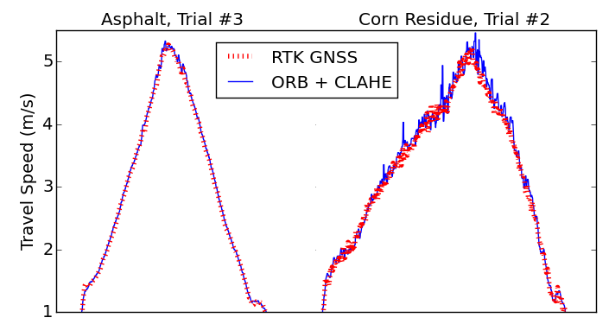
Fig. 7. Examples of trials which produced good (left) and bad (right) visual tracking.
Table 1 shows a summary of 95th percentile errors and average processing times for each combination of feature-descriptor algorithm and matching method. Including CLAHE as a pre-processing step for ORB reduced the error compared to standard ORB. SIFT performed best overall, but also exhibited the slowest computational speed.
Table 1. Summary of algorithms
 |  | 95th Percentile (m/s)
 | Hz | Overall | 1 - 2 m/s | 2 - 3 m/s | 3 - 4 m/s | 4 - 5 m/s
SURF₂₀₀₀  (1NN) | 8.7 | 0.29 | 0.17 | 0.22 | 0.30 | 0.35
SURF₂₀₀₀  (2NN) | 8.7 | 0.25 | 0.14 | 0.18 | 0.30 | 0.30
U-SURF₂₀₀₀ (1NN) | 15.1 | 0.24 | 0.16 | 0.17 | 0.25 | 0.29
U-SURF₂₀₀₀ (2NN) | 10.9 | 0.22 | 0.14 | 0.17 | 0.25 | 0.27
ORB₅₀₀  (1NN) | 34.2 | 0.25 | 0.13 | 0.16 | 0.40 | 0.32
ORB₅₀₀  (2NN) | 37.6 | 0.23 | 0.13 | 0.21 | 0.31 | 0.27
CLORB₅₀₀ (1NN) | 24.0 | 0.24 | 0.13 | 0.17 | 0.32 | 0.30
CLORB₅₀₀ (2NN) | 25.3 | 0.23 | 0.13 | 0.18 | 0.27 | 0.27
SIFT₅₀₀  (1NN) | 5.5 | 0.21 | 0.13 | 0.15 | 0.22 | 0.29
SIFT₅₀₀  (2NN) | 5.4 | 0.21 | 0.13 | 0.16 | 0.23 | 0.26
Note: subscript values indicate the keypoint threshold used for each algorithm, i.e. n-features with respect to SIFT and ORB, and the Hessian threshold with respect to SURF. This table only presents results for threshold values (among those tested) which resulted in the best overall performance with respect to both computational speed and accuracy.
Figure 8 presents the normalized frequency distribution of errors for visual tracking relative to RTK-GNSS data. Two curves are presented: 1) uncompensated ground speed, and 2) ground speeds which were corrected using a constant conversion factor based on surface height (7). The gravel, asphalt, and seedling surfaces showed negligible difference between the uncompensated and compensated methods.
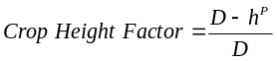 (7)
where P is the zoom power (1.0918), D is the ideal subject depth (100 cm), and h is the crop height (in cm).
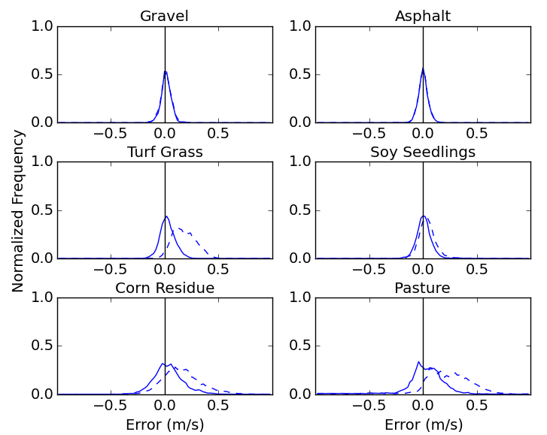
Fig. 8. Normalized frequency of errors for uncompensated (dashed) and depth compensated (solid).
Figure 9 presents a Tukey HSD multiple comparison for each feature-descriptor with respect to surface. Pasture and asphalt resulted in significantly greater variance of SURF, U-SURF, and ORB for both kNN methods. CLORB and SIFT had significantly lower variances compare to the other three feature-descriptors.
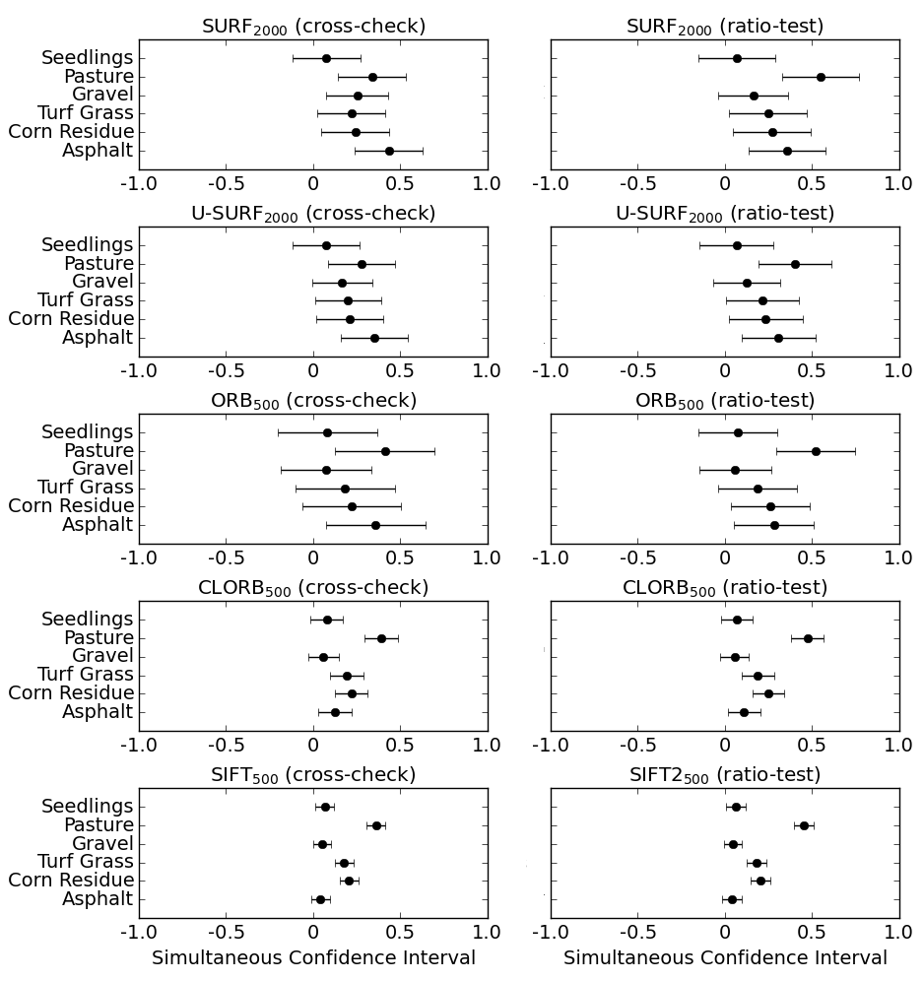
Fig. 9. Tukey HSD multiple comparison of RMSE values with respect to feature-descriptor, matcher, and surface.
Figure 10 presents the inlier-outlier ratio, i.e. the number of valid vectors compared to total matches. In general, 1NN with cross-checking demonstrated less variability than 2NN with the ratio-test.
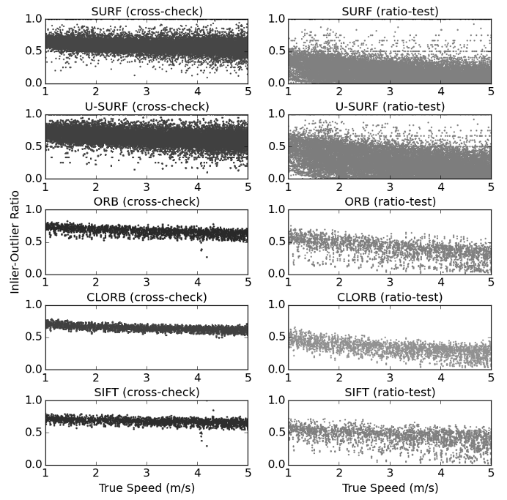
Fig. 10. Inlier-outlier ratio of each algorithm with respect to the kNN matching method used.
4. DISCUSSION
Although the ORB algorithm was computationally efficient, it demonstrated reduced accuracy for speeds from 3 to 5 m/s compared to SIFT, SURF, U-SURF, and CLORB (Table 1). U-SURF not only outperformed SURF, but was computationally faster by 50% (Table 1). Variants of the SIFT algorithm exhibited the best overall accuracy and this difference was most noticeable on asphalt (Figure 9). Incorporating CLAHE processing prior to the ORB algorithm greatly improved reliability and, despite the increased computational cost, was capable of real-time performance of greater than 25 Hz (Table 1). Overall, there was a inverse relationship between accuracy and complexity of feature-description. For example, SIFT exhibited the best precision, but also significantly slower computational time (Table 1). With respect to kNN matching, 2NN with the ratio-test produced slightly more accurate estimates (Table 1), but greater variability of inlier-outlier ratios in addition to frames with zero matches at higher travel speeds (Figure 10).
These results suggest that agricultural applications which require real-time vector estimation with low-cost cameras might consider CLORB with 1NN cross-checking due to its beneficial compromise between precision and computational speed. However, applications which require high accuracy vector estimations and do not have strict time constraints should consider U-SURF with 2NN ratio-testing due to its excellent performance on all surfaces and at all travel speeds. For tractor performance testing on concrete and asphalt, both of which are very homogeneous surfaces, SIFT had the best performance due to DoG's ability to find distinctive keypoints regardless of noise and surface homogeneity.
4.1 Future Research
Monocular visual tracking may be valuable for cultivator guidance systems due to the dynamic position of the implement relative to the tractor. Computer vision systems have already been successfully demonstrated for row detection on center-shift cultivators (Hague, 2006), but pivoting-hitch systems, such as the Sunco AcuraTrak (Sunco Manufacturing, North Platte, Nebraska, USA), pose a particular challenges for row estimation. The pivoting action of the hitch changes the orientation of implement-mounted cameras relative to the crop row. Therefore, the system will over- or under-estimate lateral error depending on tracking direction.
Guidance errors due to the motion of a pivoting-hitch can be mitigated by compensating for implement yaw with visual tracking vector information. Assuming that the longitudinal component of the implement's velocity in the direction of the crop row (V_{y}) is much greater than the rate of lateral adjustment (V_{x}), the small angle approximation applies and orientation of the image can be corrected by applying a rotational matrix transform about the pivot point.
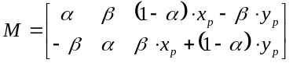 (8)
where α = cos(θ), β = sin(θ), and (x_{p}, y_{p}) is the pivot-point about which the image will be rotated (mm).
Monocular visual tracking may also be a viable component of sensor fusion systems, specifically for crop height estimation. Current methodologies for crop height detection utilize ultrasonic (Gil, 2007), LIDAR (Llorens, 2011), or stereovision systems (Kise, 2005). For modern tractors with ISOBUS, the ratio between visual tracking and RTK-GNSS groundspeed data may be sufficient for estimating the height of the crop canopy without the need for ultrasonic or laser distance sensors. Such a system may be easily integrated with existing monocular vision systems being used for sectional sprayer control.
5. CONCLUSION
Real-time visual tracking for agricultural implements has great potential for feedback and control applications. When comparing visual tracking against RTK-GNSS, ORB with CLAHE pre-processing (CLORB) and 1NN cross-checking was the most robust with respect to real-time applications. CLORB achieved 95th percentile error of 0.23 m/s and faster processing times than RTK-GNSS. These results suggest that agricultural applications which utilize low-cost cameras should consider CLORB due to the algorithm's beneficial compromise between accuracy, reliability, and computational speed.
REFERENCES
Bay, H., Ess, A., Tuytelaars, T., & Van Gool, L. (2008). Speeded-up robust features (SURF). Computer vision and image understanding, 110(3), 346-359.
Boiman, O., Shechtman, E., & Irani, M. (2008, June). In defense of nearest-neighbor based image classification. In Computer Vision and Pattern Recognition, 2008. CVPR 2008. IEEE Conference on (pp. 1-8). IEEE.
Hague, T., Tillett, N.D., & Wheeler, H. (2006). Automated crop and weed monitoring in widely spaced cereals. Precision Agriculture, 7(1), 21-32.
El Harraj, A., & Raissouni, N. (2015, January). Histo-binary combined corner enhancement (HBCCE) improved algorithm for image processing corner detection. Proc. of the International Conference on Image Processing, Computer Vision, and Pattern Recognition (IPCV), 95-101.
Gan-Mor, S., Clark, R.L., & Upchurch, B.L. (2007). Implement lateral position accuracy under RTK-GPS tractor guidance. Computers and Electronics in Agriculture, 59(1), 31-38.
Gauglitz, S., Hèollerer, T., & Turk, M. (2011). Evaluation of Interest Point Detectors and Feature Descriptors for Visual Tracking. International Journal of Computer Vision, 94( 3), 335-360.
Gil, E., Escolà, A., Rosell, J.R., Planas, S., & Val, L. (2007). Variable rate application of plant protection products in vineyard using ultrasonic sensors. Crop Protection, 26(8), 1287-1297.
Kise, M., Zhang, Q., & Más, F. R. (2005). A stereovision-based crop row detection method for tractor-automated guidance. Biosystems Engineering, 90(4), 357-367.
Lowe, D. (2004). Distinctive image features from local scale-invariant keypoints. International Journal of Computer Vision, 60(2), 91-110.
Lee, S. H., Lee, S. K., & Choi, J. S. (2009). Correction of radial distortion using a planar checkerboard pattern and its image. IEEE Transactions on Consumer Electronics, 55(1), 27-33.
Nistér, D., Naroditsky, O., & Bergen, J. (2006). Visual odometry for ground vehicle applications. Journal of Field Robotics, 23(1), 3-20.
Pizer, S. M., Johnston, R. E., Ericksen, J. P., Yankaskas, B. C., & Muller, K. E. (1990). Contrast-limited adaptive histogram equalization: speed and effectiveness. Proc. of the First Conf. on Visualization in Biomedical Computing, 337-345.
Rosten, E., Porter, R., & Drummond, T. (2010). Faster and better: A machine learning approach to corner detection. Pattern Analysis and Machine Intelligence, IEEE Transactions on, 32(1), 105-119.
Rublee, E., Rabaud, V., Konolige, K., & Bradski, G. (2011). ORB: an efficient alternative to SIFT or SURF. IEEE International Conf. on Computer Vision, 2564-2571.
Thansandote, A., Stuchly, S.S., Mladek, J., Townsend, J.S., & Shlosser, H. (1977). A new slip monitor for traction equipment. Transactions of the ASAE, 20(5), 851-856.
Tompkins, F.D., Hart, W.E., Freeland, R. S., Wilkerson, J.B., & Wilhelm, L.R. (1988). Comparison of tractor ground speed measurement techniques. Transactions of the ASAE, 31(2), 369-374.
Van der Walt, S., Colbert, S.C., & Varoquaux, G. (2011). The NumPy Array: A Structure for Efficient Numerical Computation. Computing in Science & Engineering, 13, 22-30.
Yadav, G., Maheshwari, S., & Agarwal, A. (2014). Contrast limited adaptive histogram equalization based enhancement for real time video system. Communications and Informatics International Conference on Advances in Computing, 2392-2397.
Zuiderveld, K. (1994). Contrast limited adaptive histogram equalization. Graphics gems IV, 474-485. Academic Press Professional, Inc..

